New DC Roam Firmware Update (Ver. 0925)
- Firstly, upgrade the firmware (IocRelease-ssd202-BootUpgradeDC202-dc-20260925-082555.zip), wait 30 seconds and reboot the charger.
- Upgrade the second firmware (IocRelease-CombinationPackage-Portable202-20260618-191757), wait 1 min and reboot the charger
- Upgrade the third firmware (IocRelease-CombinationPackage-PortableWeb-20260618-191757.zip), wait 1 min and reboot the charger
Download the log and open the zipfile, and check boot_upgrade_indep.xxxxxxx.log
Ctrl+F quick search ‘upgrade_handle.’ , to see all commands with ,pass.
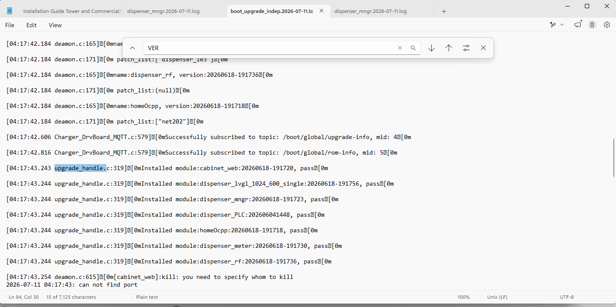

- Upgrade the third firmware (IocRelease-b103-dispenser_103-20260604-190501), wait 3 mins, power-cycle the charger
Download the log and open the zipfile, and check the dispenser_mngr.xxxxx.log.
Ctrl+F quick search ‘swVer’ and you will find swVer 00000000 -> xxxxx, if xxxxx is larger than 20260201, then it proves the firmware update is successful.
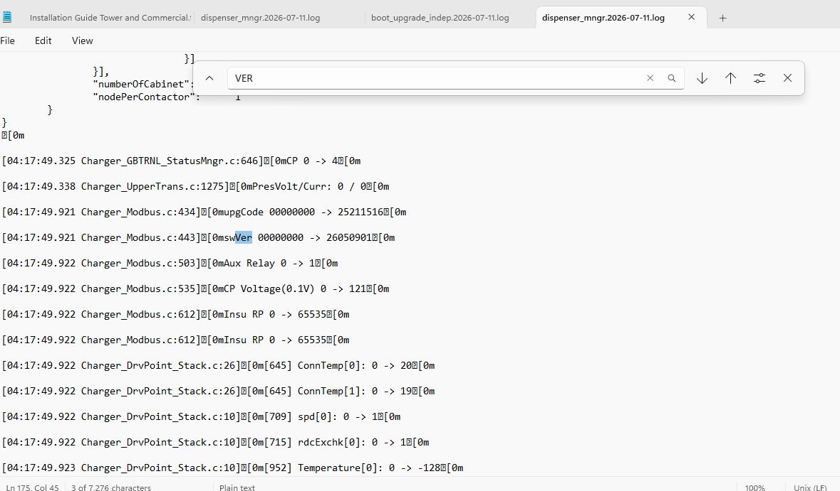
- Please check the App version, then conduct the test.
